18.Implement image cropping, copying and pasting to select a region of interest (ROI) from the source image using Open CV.

AIM:

To implement the Sobel Edge Detection Algorithm using OpenCV to filter an input image.

PROCEDURE:

1. Install OpenCV if not already installed using:

* pip install opencv-python

1. Import the required libraries (cv2 and numpy).
2. Read the input image using cv2.imread().
3. Convert the image to grayscale using cv2.cvtColor().
4. Apply the Sobel filter in the X and Y directions using cv2.Sobel().
5. Compute the absolute gradient magnitude using cv2.convertScaleAbs().
6. Combine the X and Y gradients using cv2.addWeighted().
7. Display the original, Sobel X, Sobel Y, and combined edge images using cv2.imshow().
8. Save the output images using cv2.imwrite(), if needed.
9. Wait for a key press and close all image windows using cv2.waitKey(0) and cv2.destroyAllWindows().

PROGRAM:

import cv2

import numpy as np

# Read the input image

image = cv2.imread("image.jpg") # Replace with your image file path

# Convert the image to grayscale

gray = cv2.cvtColor(image, cv2.COLOR_BGR2GRAY)

# Apply Sobel filter in X and Y directions

sobel_x = cv2.Sobel(gray, cv2.CV_64F, 1, 0, ksize=3) # Gradient in X direction

sobel_y = cv2.Sobel(gray, cv2.CV_64F, 0, 1, ksize=3) # Gradient in Y direction

# Convert gradients to absolute scale

sobel_x = cv2.convertScaleAbs(sobel_x)

sobel_y = cv2.convertScaleAbs(sobel_y)

# Combine the gradients

sobel_combined = cv2.addWeighted(sobel_x, 0.5, sobel_y, 0.5, 0)

# Display images

cv2.imshow("Original Image", image)

cv2.imshow("Sobel X", sobel_x)

cv2.imshow("Sobel Y", sobel_y)

cv2.imshow("Sobel Combined", sobel_combined)

# Save the results

cv2.imwrite("sobel_x.jpg", sobel_x)

cv2.imwrite("sobel_y.jpg", sobel_y)

cv2.imwrite("sobel_combined.jpg", sobel_combined)

# Wait for a key press and close all windows

cv2.waitKey(0)

cv2.destroyAllWindows()

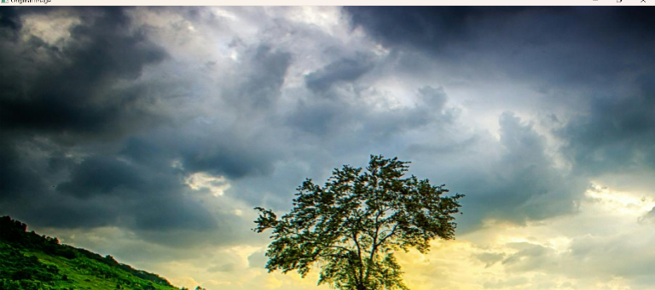

INPUT:

OUTPUT:

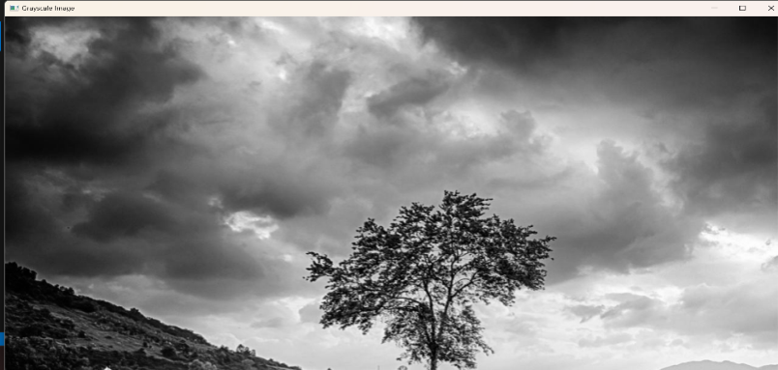

RESULT :

The program successfully applies the Sobel Edge Detection Algorithm to the given image, detects edges in both directions, displays the results, and saves them as "sobel_x.jpg", "sobel_y.jpg", and "sobel_combined.jpg".